

**IT3010**

**Network Design & Management**

**3rd Year, 1st Semester**

<Lab 01 & 02 >

**<Assignment /Lab Report 01>**

Submitted to

Sri Lanka Institute of Information Technology

In partial fulfillment of the requirements for the

Bachelor of Science Special Honors Degree in Information Technology

2/27/2024

1. A screenshot of a computer

   Description automatically generated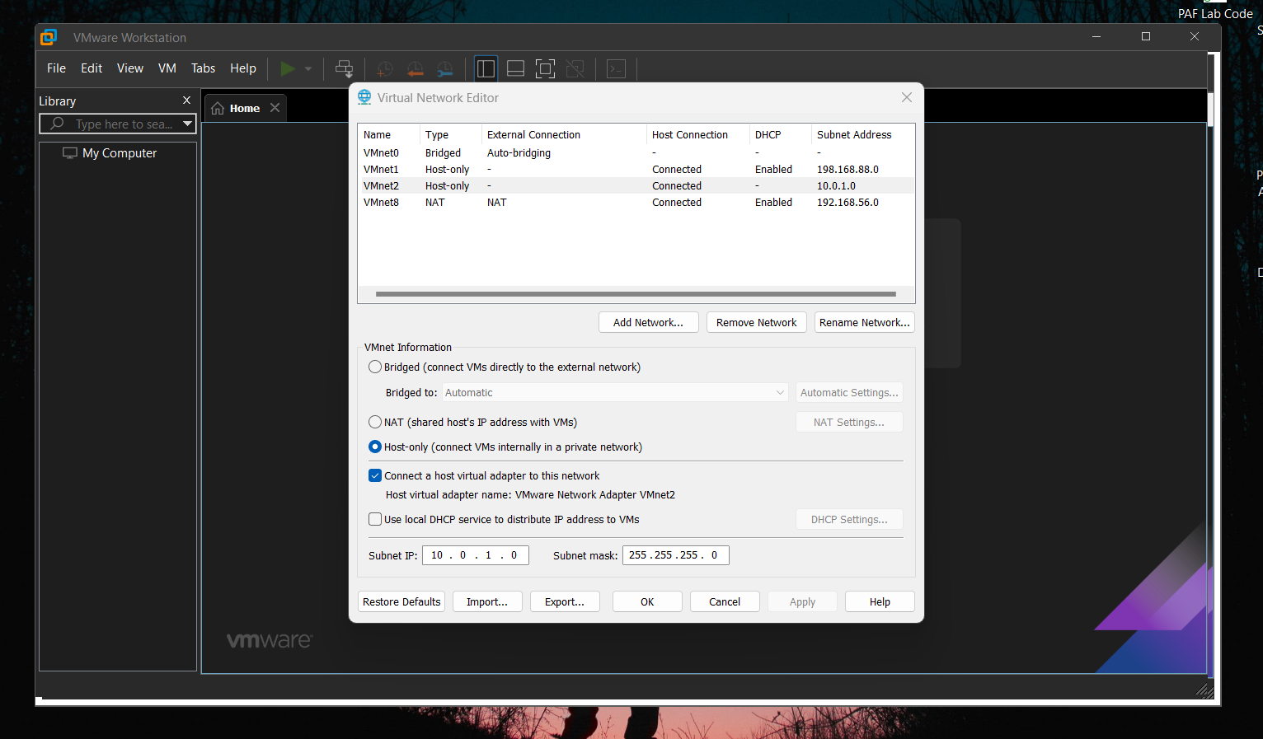Virtual Network Edit in VMware Workstations.

Open VMware Workstation and navigate to the VMware address "VMware0." Add a new virtual network. Lastly, change the IP and click on the "Apply" button.

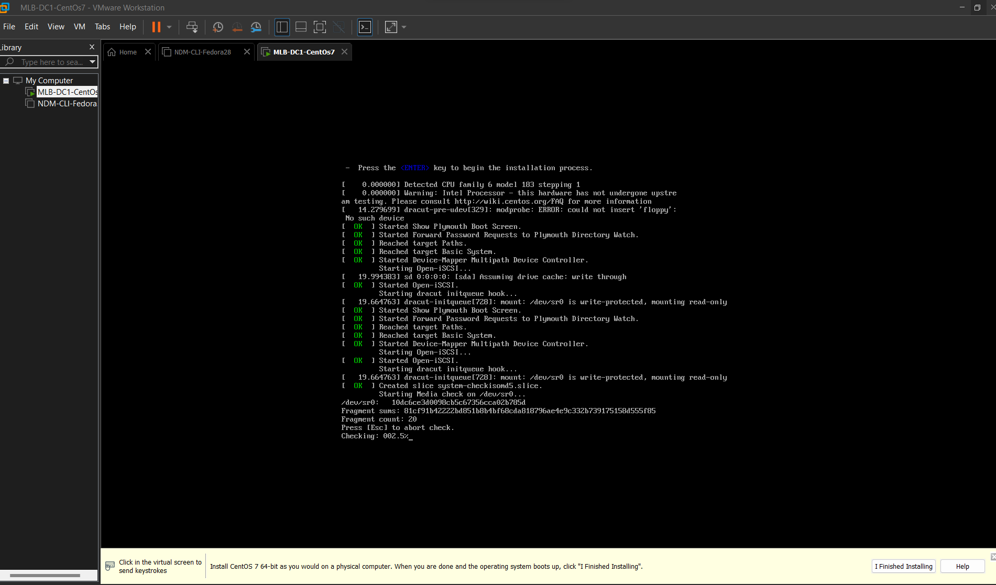02.Install CentOs7

First, set up the workstation board, and navigate to the NDM server folder for installation. Import it into the CentOS program files through the browser. Lastly, run the installation by clicking on "install."

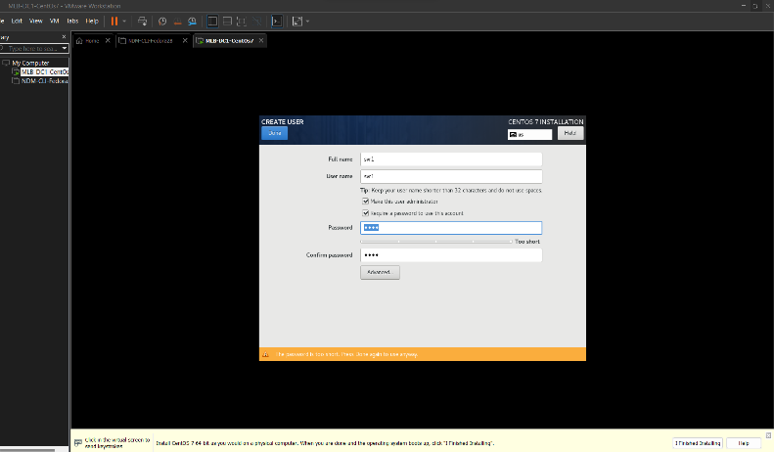Set up the CentOS profile.

Setup Profile

Setup root Password

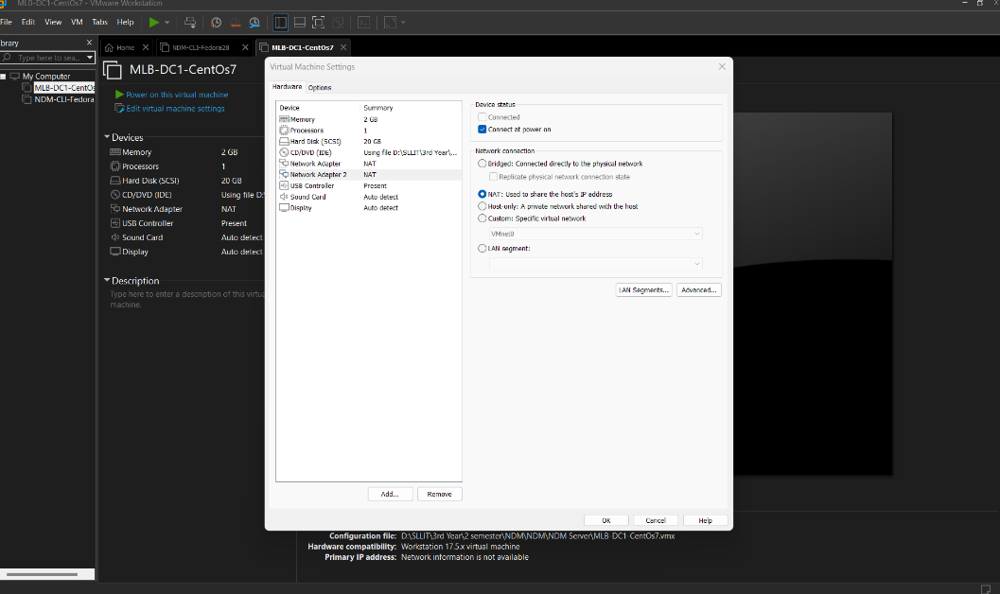**0**3.Create a New Network Adapter CentOs7 and Fedora Workstation.

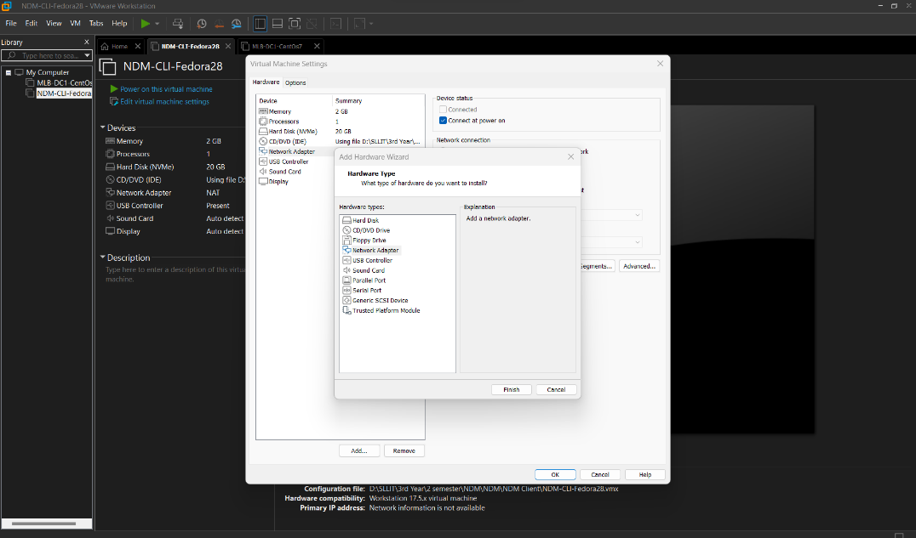

04.Fedora Workstation Install

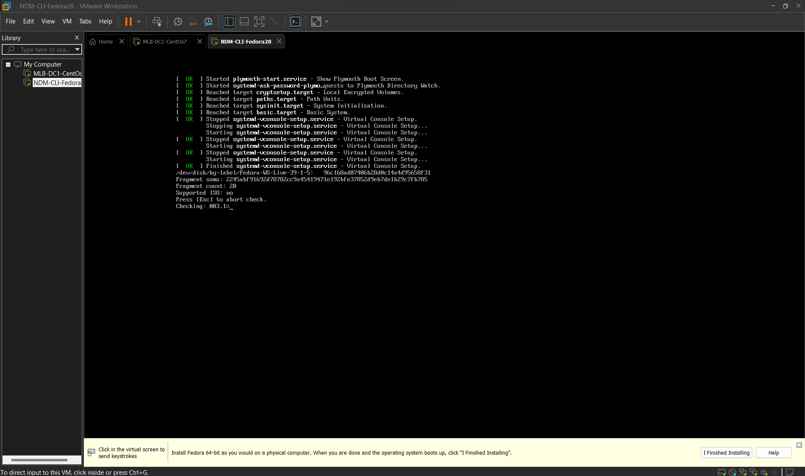

Fedora Dashboard And Install Fedora Applications.

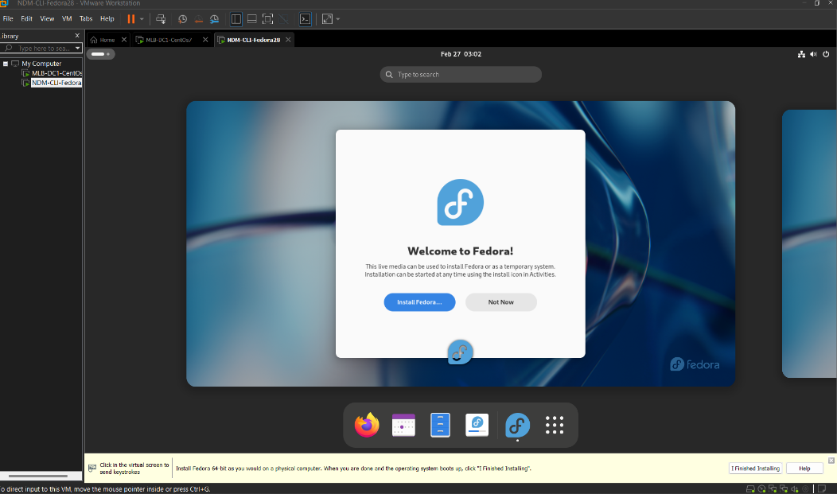

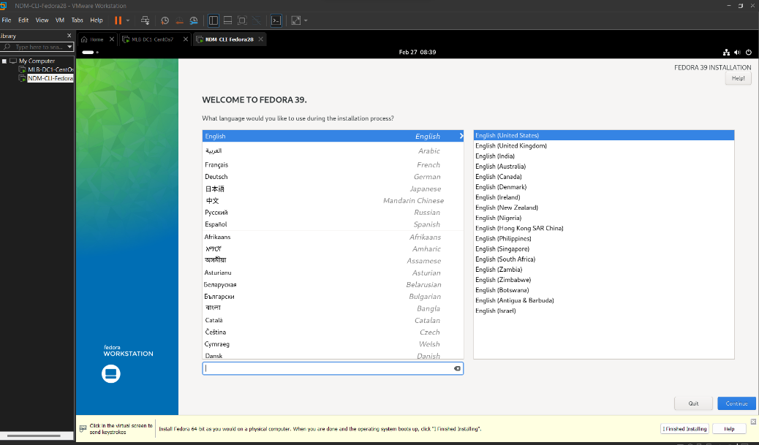

Create a username and password.

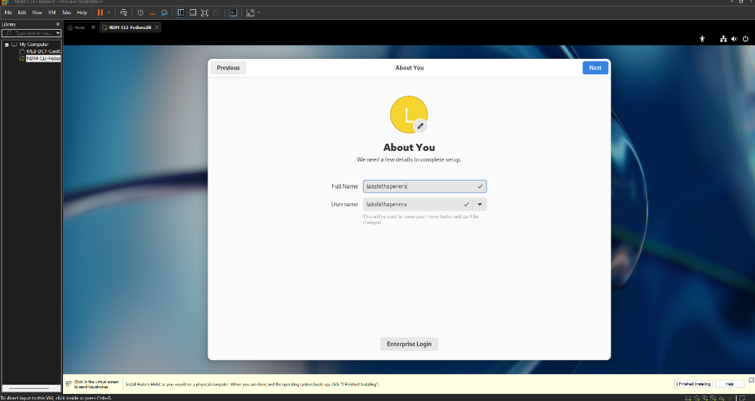

Change hostname in fedora workstation.

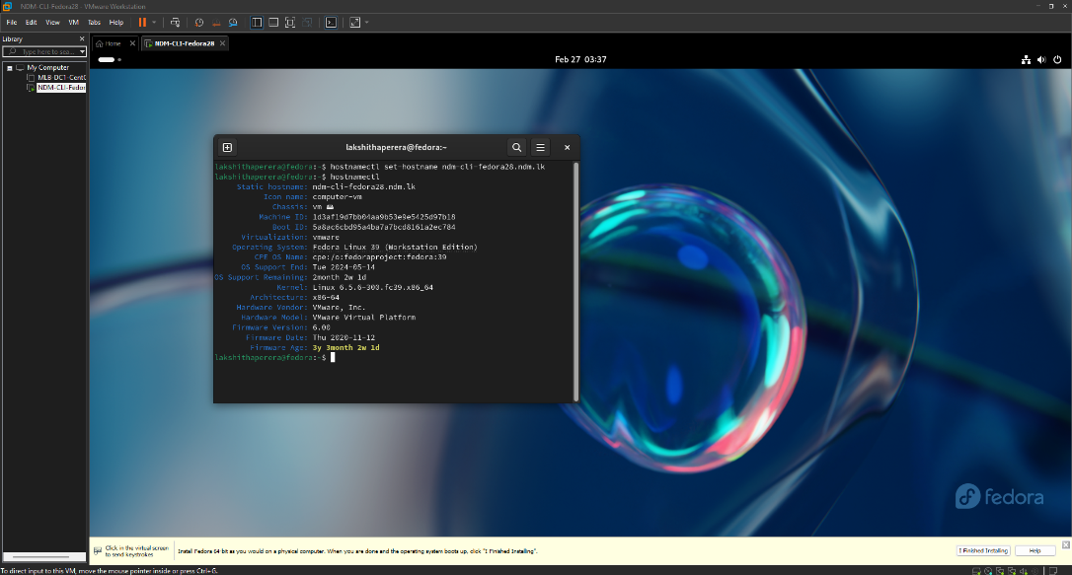

05. Change the IP address in CentOS.

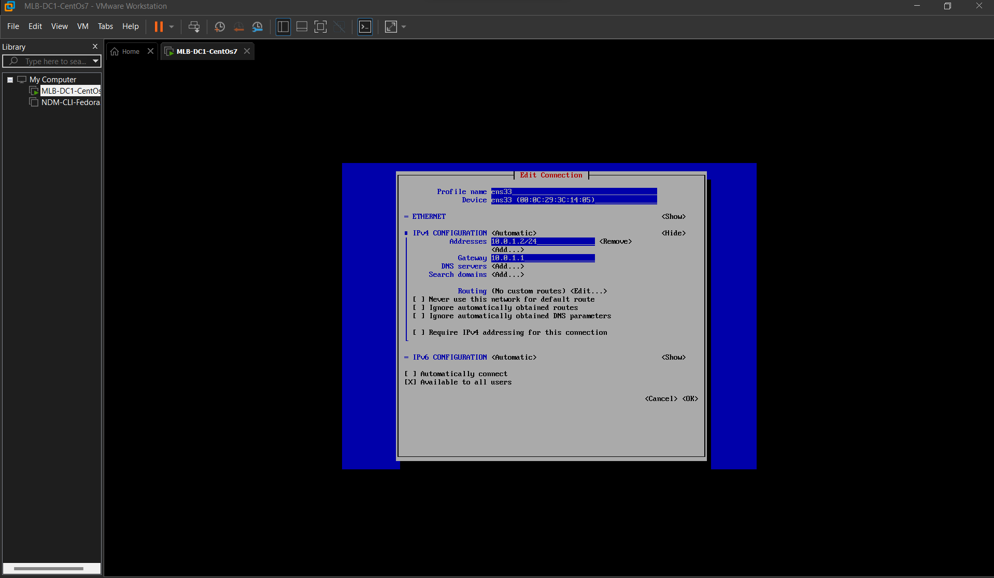

Activate and deactivate Ethernet connections.

Change the IP address in Fedora Workstation.

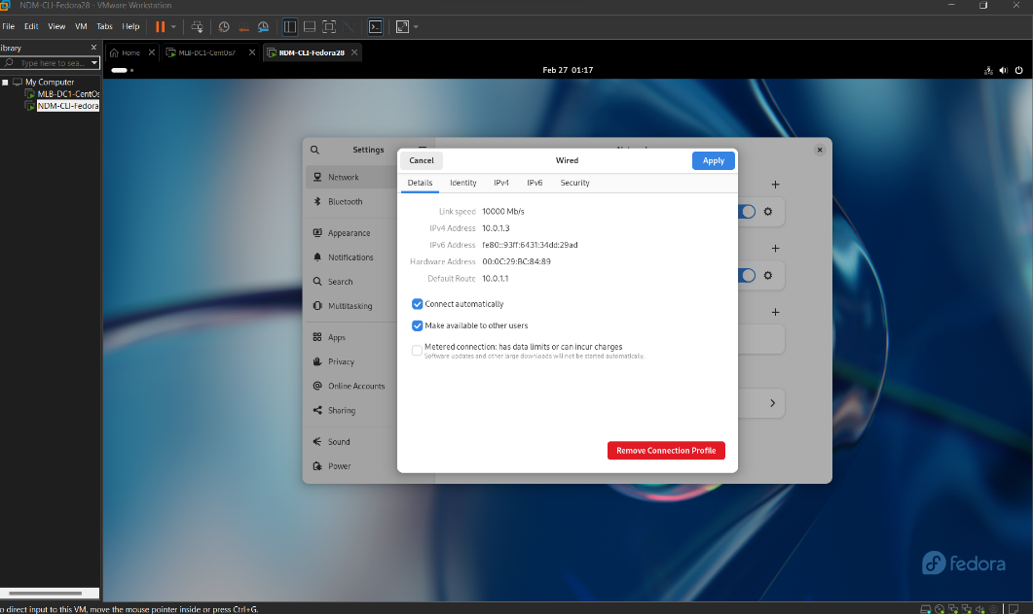

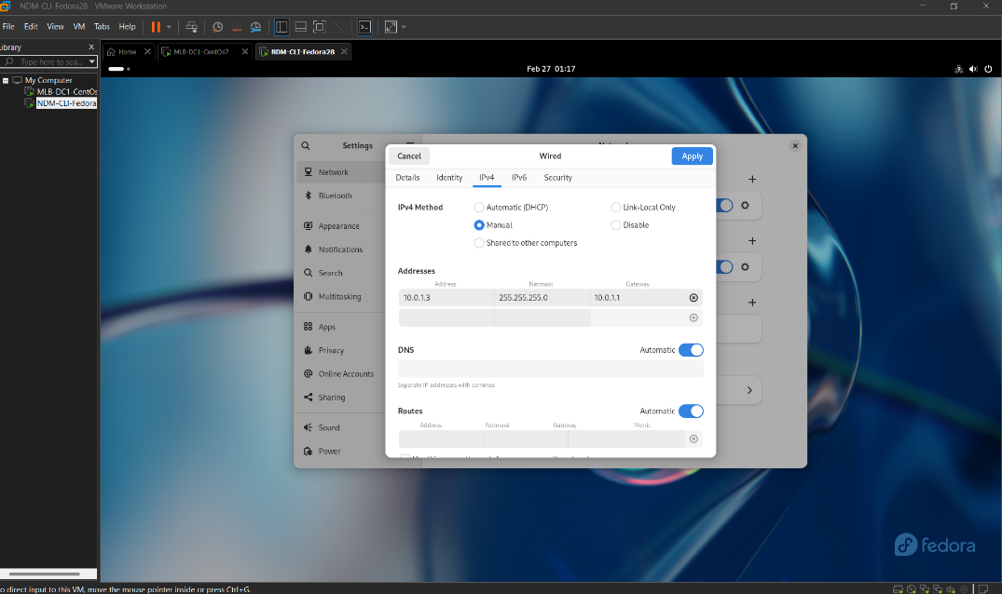

**Lab 02**

Check the connection and install DHCPd.

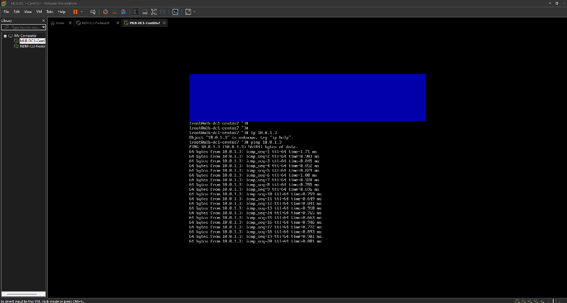

DHCP Install.

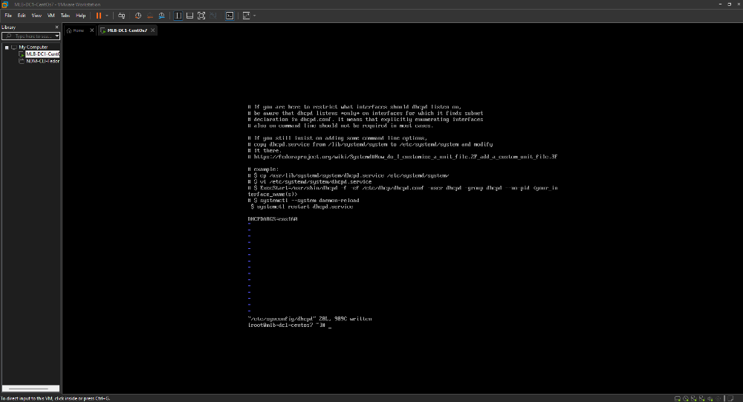Configuring DHCP settings.

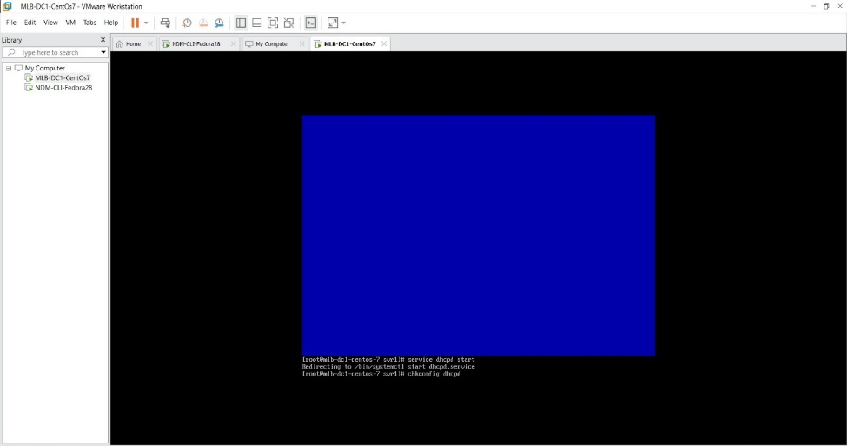

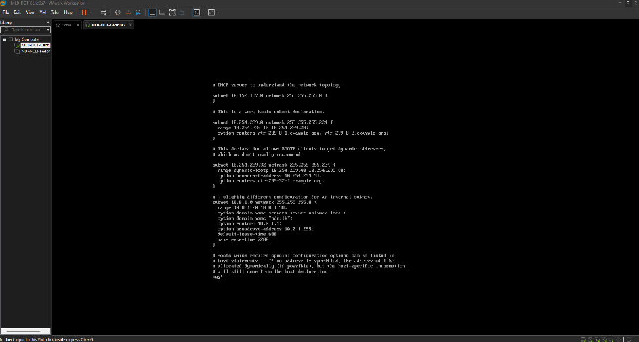

**Declaration**

I certify that this report does not incorporate without acknowledgement, any material previously submitted for a degree or diploma in any university, and to the best of my knowledge and belief it does not contain any material previously published or written by another person, except where due reference is made in text.

Registration Number :

Name :

***Important:***

*Remember*

* *Plagiarism is considered as a serious crime against intellectual property in academic environments.*
* *By including the declaration page mentioned below, you abide by the laws of the institute to accept 0 marks for the report, in case you get caught attempting plagiarism.*

**Instructions for submission**

1. Change the red colored components accordingly and include page numbers.
2. Use PDF for Word formats for submission
3. Rename the submission document as follows;

RegistrationNo_Lab/Assignment_Lab/Assignment Name or Number

e.g.

IT12345678_Lab_1.docx

**General Formatting**

1. Paper size: A4
2. Contents font & size: Times New Roman, size 12
3. Chapter headings/sub headings font & size: Times New Roman Bold, size 12
4. Page numbering:
   * Cover page should not contain any number
   * Declaration page to table of figures page should be numbered using Roman numbers at bottom center of the page
   * Content pages, references page(s) and annexes (if any) should be numbered using Arabic numbers at the bottom center of the page
5. Margins: 1 inch margins on left, right, top and bottom
6. Line spacing: 1.5 line spacing

**Figure Numbering:**

1. Each figure should be numbered at bottom center of the figure along with a figure name.
2. Figure number should start with word ‘Figure’ followed by the ‘main chapter number’ and ‘figure number within the chapter’ separated by a ‘period sign (.)’ and followed by a ‘colon (:)’.

For example,

Figure 2.6: XYZ Connector

**Declaration Page:**

Reports that does not contain this declaration ‘AS IS’ will not be accepted as valid reports and will be awarded 0 marks.